Project‭ Report On‬



**ShopInn‭ (Shopping Site)‬**

Submitted‭ in partial fulfillment for the award of‬

**Post‭ Graduate Diploma in Advanced Computing‬**

from‬‭

**C‭-DAC ACTS (Pune)‬**,‬‭

**Guided‭ by‬**

**Mr‭. Vinu Josy‬**,‬‭

**Presented‭ By‬**:‬‭

**Priyanshu‭ Shukla - 240340120141‬**

**Rahul‭ Mishra- 240340120142‬**

**Sagar‭ Negi – 240340120161‬**

**Varun‭ Khadse - 240340120220‬**



**‭Centre of Development of Advanced Computing (C-DAC),‬**

**‭Pune,Maharashtra.‬**



**CERTIFICATE‭‬**

**TO‭ WHOMSOEVER IT MAY CONCERN‬**

This‭ is to certify that‬

**Priyanshu‭ Shukla - 240340120141‬**

**Rahul‭ Mishra- 240340120142‬**

**Sagar‭ Negi – 240340120161‬**

**Varun‭ Khadse - 240340120220‬**

have‭ successfully completed their‬**project‬‭**titled‬‭

**“ShopInn‭ (Shopping Site)”‬**

Under‭ the‬**Guidance‬‭**of‬‭ **Mr‭. Vinu Josy‬**

**‭Project Guide‬** **‭HOD ACTS‬**





**ACKNOWLEDGEMENT‬‭**

‭This project‬**‭“‬‭ShopInn (Shopping Site)‬‭”‬**‭was a great learning experience‬ ‭for us and we are submitting this work to Advanced Computing Training School‬ ‭(CDAC ACTS).‬

We‭ all are very glad to mention the name of‬**Mr‭. Vinu Josy‬**for‭ his valuable‬

guidance‭ to work on this project. His guidance and support helped us to overcome‬ ‭various obstacles and intricacies during the course of project work.‬

Our‭ most heartfelt thank goes to Ms‬**Namrata‭ mam‬**(Course‭ Coordinator, PG‬

DAC)‭ who gave all the required support and kind coordination to provide all the‬

‭necessities like required hardware, internet facility and extra Lab hours to complete‬ ‭the project and throughout the course up to the last day here in C-DAC ACTS,‬

Pune‭.‬

Priyanshu‭ Shukla - 240340120141‬

Rahul‭ Mishra- 240340120142‬

Sagar‭ Negi – 240340120161‬

Varun‭ Khadse - 240340120220‬



**TABLE‭ OF CONTENTS‬**



1‭. Introduction‬

2‭. Software Requirement and specification‬

3‭. Tools and technologies used‬

4‭. Project Flow Diagram‬

5‭. ER Diagram‬

6‭. Advantages‬

7‭. Screenshots‬

8‭. Future Scope‬

9‭. Conclusion‬

10‭.References‬



**1‭. Introduction‬**



Book‬‭ Charm‬‭ is‬‭ an‬‭ innovative‬‭ e‭-commerce‬ web‬‭ application‬‭ tailored‬‭ for‬‭ a‬‭

delightful‬‭ book‬‭ shopping‬‭ experience‭.‬ This‬‭ platform‬‭ caters‬‭ to‬‭ book‬‭ enthusiasts,‬‭

offering‬‭a‬‭wide‬‭array‬‭of‬‭genres‬‭and‬‭titles‭.‬‭Users‬‭can‬‭seamlessly‬‭browse,‬‭search,‬‭and‬

purchase‭ books, creating an engaging and user-friendly environment..‬

Powered‬‭ by‬‭ a‬‭ blend‬‭ of‬‭ cutting‭-edge‬ technologies,‬‭ Book‭-charm‬ redefines‬‭ the‬‭

way‬‭ users‬‭ engage‬‭ with‬‭ books‬‭ content‬‭ online‭.‬ Leveraging‬‭ the‬‭ robustness‬‭ and‬‭

versatility‬‭ofSpring‬‭Boot,‬‭ **Spring‬‭Data‬‭JPA‬‭**,‬‭and‬‭RESTful‬‭Web‬‭Services,‬‭we‬‭have‬‭

engineered‬‭ a‬‭ backend‬‭ infrastructure‬‭ that‬‭ ensures‬‭ reliable‬‭ user‬‭ authentication‬‭ and‬‭

efficient‬‭data‬‭retrieval‭.‬‭This‬‭foundation‬‭enables‬‭seamless‬‭integration‬‭of‬‭diverse‬‭data‬ sources‬‭and‬‭smooth‬‭communication‬‭between‬‭the‬‭server‬‭and‬‭client‬‭components‬‭of‬‭the‬‭

application‭.‬‭The‬‭application‬‭leverages‬‭a‬‭robust‬‭technology‬‭stack,‬‭including‬ **Spring‬‭**

**Boot‬‭** and‬‭ **Node‭.js‬** on‬‭the‬‭backend,‬‭ **Express‬‭** for‬‭server‭-side‬‭scripting,‬ **React‭.js‬**for‬‭

the‬‭ frontend,‬‭ and‬‭ standard‬‭ web‬‭ technologies‬‭ like‬‭ HTML‬‭ and‬‭ CSS‭.‬ Data‬‭ is‬‭

efficiently‬‭ managed‬‭using‬‭the‬‭ **MySQL‬‭Aiven‬‭cloud‬‭database‬‭** along‬‭with‬‭various‬‭

libraries‭ to enhance functionality and performance.‬

Ensuring‬‭ a‬‭ comprehensive‬‭ service,‬‭ Book‬‭ Charm‬‭ integrates‬‭ secure‬‭ **payment‬‭**

**gateways‬‭** like‬‭ Razor‭-pay‬ for‬‭ seamless‬‭ end‭-to-end‬ transactions‭.‬ Users‬‭ can‬‭

confidently‬‭ make‬‭ purchases‬‭ with‬‭ a‬‭ variety‬‭ of‬‭ payment‬‭ options,‬‭ enhancing‬‭ the‬‭

overall‭ convenience of the shopping process.‬ Furthermore,‬‭the‬‭project's‬‭frontend‬‭is‬‭meticulously‬‭crafted‬‭using‬‭React‬‭and‬‭CSS,‬‭

resulting‬‭ in‬‭ an‬‭ immersive‬‭ and‬‭ visually‬‭ appealing‬‭ user‬‭ interface‭.‬ The‬‭ login‬‭ and‬‭

registration‬‭ functionalities,‬‭ prominently‬‭ featured‬‭ at‬‭ the‬‭ outset,‬‭ empower‬‭ users‬‭ to‬‭

personalize‭ their experience and access exclusive features seamlessly.‬

Book‬‭Charm‬‭prioritizes‬‭a‬‭user‭-responsive‬‭design,‬‭ensuring‬‭an‬‭optimal‬‭experience‬

across‬‭devices‭.‬‭The‬‭website‬‭dynamically‬‭adjusts‬‭its‬‭layout‬‭and‬‭features‬‭to‬‭provide‬ an‭ intuitive and visually appealing interface.‬

The‬‭ responsiveness‬‭ of‬‭ Book‬‭ Charm‬‭ extends‬‭ beyond‬‭ mere‬‭ adaptability‭.‬ The‬‭

website‬‭employs‬‭a‬‭fluid‬‭design‬‭that‬‭not‬‭only‬‭scales‬‭seamlessly‬‭but‬‭also‬‭optimizes‬‭

content‬‭ presentation‭.‬ Touch‭-friendly‬ buttons,‬‭ intuitive‬‭ navigation,‬‭ and‬‭ efficient‬‭

loading‬‭ times‬‭ contribute‬‭ to‬‭ a‬‭ smooth‬‭and‬‭immersive‬‭user‬‭experience‭.‬‭Leveraging‬

React‭.js‬‭for‬‭dynamic‬‭content‬‭rendering,‬‭Book‬‭Charm‬‭ensures‬‭real-time‬‭updates‬‭and‬ a‬‭personalized‬‭touch,‬‭enhancing‬‭user‬‭satisfaction‬‭and‬‭fostering‬‭a‬‭strong‬‭connection‬‭

with‬‭ the‬‭ platform‭.‬ The‬‭ commitment‬‭to‬‭responsiveness‬‭underscores‬‭Book‬‭Charm's‬‭

dedication‬‭ to‬‭ delivering‬‭ a‬‭ modern,‬‭ accessible,‬‭ and‬‭ enjoyable‬‭ online‬‭ bookstore‬‭

experience‭ for all users.‬

**2‭.Software/Hardware Requirement‬**



**Server:‬‭**

Processor:‭ Intel Core i5 or equivalent AMD processor.‬

RAM:‭ Minimum 8GB RAM.‬

Storage:‭ SSD storage for improved performance.‬

Network:‭ Ethernet or Wi-Fi connectivity.‬

Operating‭ System: Linux distribution (Ubuntu, CentOS) preferred for‬

server‭ deployment.‬

**Client‭ Devices:‬**

Processor:‭ Dual-core processor or higher.‬

RAM:‭ Minimum 4GB RAM.‬

Storage:‭ Sufficient storage for caching and local data.‬

Network:‭ Ethernet or Wi-Fi connectivity.‬

Browser:‭ Compatible with latest versions of popular browsers like Google‬

Chrome,‭ Mozilla Firefox, and Safari.‬

**3‭. Tools and technologies used‬**



‭●‬‭SpringBoot‬

‭●‬‭SpringDataJPA‬

‭●‬‭RESTful Web‬

●‬‭Node‭ JS‬

‭●‬‭Express JS‬

‭●‬‭SpringWeb‬

●‬‭MYSQL‭ Aiven Cloud Database‬

●‬‭JWT‬‭

●‬‭Git‬‭

‭●‬‭Spring Security‬

●‬‭React‭ JS‬

●‬‭HTML‭ and CSS‬

●‬‭Axios‬‭

‭●‬‭Razor-pay payment integration‬

●‬‭Material‭ UI‬

1‭. Spring Boot: Utilized to develop the backend of the application, providing a robust‬

framework‭ for building Java-based web applications with ease.‬

2‭. Spring Data JPA: Implemented for data access, allowing seamless interaction with the‬

MySQL‭ database to store and retrieve sports data efficiently.‬

3‭. RESTful Web Services: In the context of an e-commerce web application like Book‬

Charm,‭ RESTful web services play a crucial role in facilitating communication‬

between‭ the frontend and backend components. These services adhere to the principles‬ of‭ Representational State Transfer (REST), which emphasizes a stateless, standardized‬

approach‭ for building web services‬

4‭. Node JS: Employed for web scraping, enabling the application to extract live scores‬

andmatch‭ details from various sports websites and APIs.‬

5‭. Express JS: Express.js is a web application framework for Node.js that simplifies the‬

creation‭ of robust, scalable APIs and web applications by providing a set of‬

middleware‭ and routing mechanisms. It streamlines the process of handling HTTP‬

requests,‭ making it efficient for building server-side components in a Node.js‬

application‭.‬

6‭. Spring Web: Used for handling web requests and responses, managing controllers, and‬

serving‭ static resources to the frontend.‬

7‭. Aiven cloud database MySQL: Chosen as the relational database management‬

system‭ to store book data on cloud ,including user detail ,seller detail, book‬

information‭ and admin details.‬

8‭. JWT (JSON Web Tokens): Implemented for secure user authentication and‬

authorization,‭ ensuring that only authenticated users can access into account and buy‬

books‭ and seller can add books .‬

9‭. Axios: In the context of a web application like Book Charm, Axios is likely used as a‬ client‭-side HTTP library. Axios simplifies the process of making asynchronous HTTP‬

requests‭ from the frontend (React.js) to the backend (Node.js/Express.js). It is‬

instrumental‭ in fetching data from the server, handling API calls, and facilitating‬

smooth‭ communication between the frontend and backend components, ensuring‬

efficient‭ data retrieval and seamless user interactions in the e-commerce application‬

10‭. React: Employed to build the frontend of the application, offering a‬

component‭-based architecture for creating dynamic and interactive user interfaces.‬

‭11. CSS: Used for styling the frontend components with utility-first CSS‬

classes,allowing‭ for rapid prototyping and customization of the user interface.‬

12‭. Material UI: Leveraged to enhance the visual appeal and user experience of the‬

application‭ by incorporating pre-designed React components following‬

Google's‭ Material Design principles.‬

13‭. Git: Implemented as a version control system to track changes in the source‬

code,‭ enabling collaboration among developers, and facilitating code‬

management‭ and deployment workflows.‬

14‭. Razor-pay Payment Integration: In the Book Charm project, Razorpay is‬

integrated‭ as the payment gateway, enabling secure and streamlined online‬

transactions‭. Razorpay provides a developer-friendly API, allowing seamless‬

integration‭ for processing payments, managing subscriptions, and ensuring a‬

reliable‭ end-to-end payment experience for users in the e-commerce web‬ application‬‭

**4‭. Project Database Diagram‬**



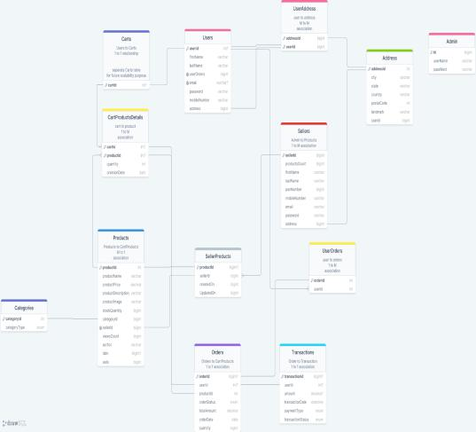

Book‭-Charm‬

**5‭.Project E-R(Entity relationship) Diagram‬**



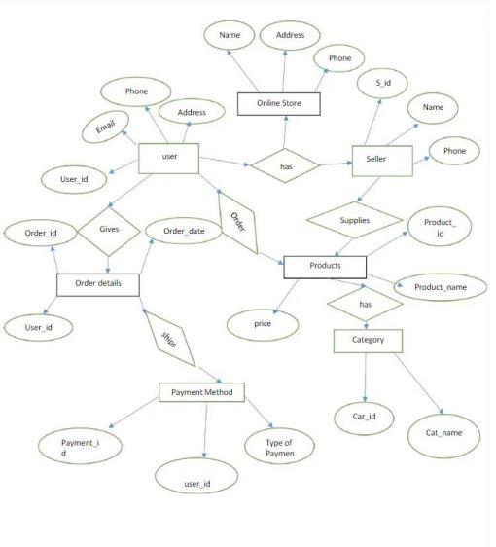

Book‭-Charm‬

**‭6. Advantages‬**



●‬‭Use‭ of MySQL Cloud Database(aiven)‬

‭○‬‭The Book Charm project utilizes the Aiven cloud-based‬‭MySQL database for‬ ‭efficient and scalable data management. Here are key points about its‬ ‭integration:‬

‭○‬‭1. Reliability: Aiven offers a reliable database‬‭solution with high availability, ensuring‬ ‭uninterrupted service for Book Charm users.‬

○‬‭2‭.Scalability: The cloud-based nature of Aiven allows‬‭seamless scalability,‬

accommodating‭ the growing data needs of the e-commerce application.‬

○‬‭3‭.Managed Services: Aiven provides managed MySQL‬‭services, handling‬

administrative‭ tasks such as backups and maintenance, reducing the operational burden‬ on‭ the development team.‬

○‬‭4‭.Security: The Aiven platform prioritizes data‬‭security, implementing encryption and‬

access‭ controls to safeguard sensitive information stored in the MySQL database.‬

○‬‭5‭.Automatic Backups: Book Charm benefits from automatic‬‭backups provided by‬

Aiven,‭ ensuring data integrity and easy recovery in case of unexpected issues.‬

‭○‬‭6.API Compatibility: Aiven supports standard MySQL APIs, facilitating seamless‬ ‭integration with the backend components of the Book Charm web application.‬

○‬‭7‭.Developer-Friendly: The Aiven platform offers‬‭a developer-friendly environment,‬

making‭ it straightforward for the development team to configure and manage the‬

MySQL‭ database for Book Charm.‬

○‬‭8‭.Cost-Effective: Aiven's cloud-based model allows‬‭cost-effective utilization, enabling‬

Book‭ Charm to pay for the resources it consumes without the need for extensive‬

‭infrastructure management.‬

‭○‬‭9.Data Durability: With Aiven, data durability is‬‭enhanced through redundant storage‬

‭and backup mechanisms, ensuring that critical information is safeguarded against data‬

loss‭ scenarios.‬

‭∙‬‭Use of JWT for authorization‬

‭○‬‭Stateless Authentication: JWT allows for stateless‬‭authentication, meaning server-side‬

sessions‭ or database lookups for authentication are not required, resulting in reduced‬

server‭ load and improved scalability.‬

‭○‬ ‭Enhanced‬‭Security:‬‭JWTs‬‭are‬‭digitally‬‭signed,‬‭ensuring‬‭data‬‭integrity‬‭and‬‭preventing‬ ‭tampering‬‭or‬‭unauthorized‬‭access‬‭to‬‭user‬‭data.‬‭Additionally,‬‭since‬‭JWTs‬‭do‬‭not‬‭store‬

sensitive‭ information, they mitigate the risk of data exposure in case of a breach.‬

○‬‭Cross‭-Domain Compatibility: JWTs can be easily transmitted‬‭over HTTP headers or‬

URLs,‭ making them suitable for use in cross-domain communication and enabling‬ ‭seamless integration with various frontend and backend technologies.‬

**7‭. Screenshots‬**



**A)User‭ Related Functionalities‬**

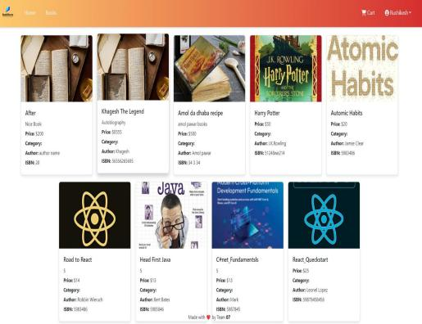

**Fig‭-1: Home Page‬**

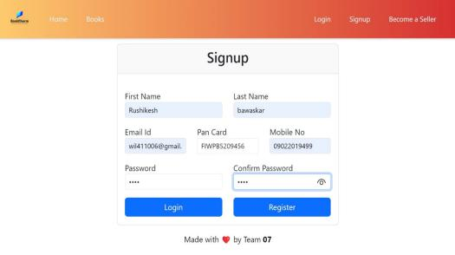

**Fig2‭ – User Registration page‬**

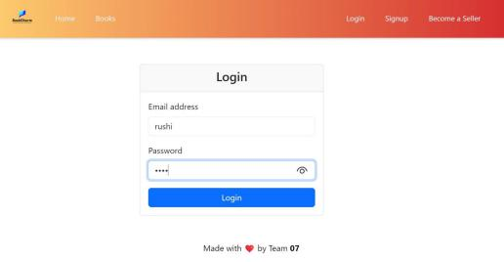

**Fig‭ 3 –User login page‬**



**‭Fig 4 –User Authenticated page‬**



**Fig‭ 5 –Book added to cart by user‬**



**Fig‭ 6 –Cart‬**

**‭B)Seller Related Functionalities‬**



**Fig‭ 7 – Seller Registration Page‬**



**‭Fig 8 – Seller Login Page‬**



**Fig‭ 9 – Seller can add book‬**

**C)Admin‭ Related Functionalities‬**



**‭Fig 10 – Admin Login page‬**



**Fig‭ 11 – Admin Dashboard(Admin can verify seller )‬ D)‭ Use Case Diagram‬**





**8‭. FUTURE SCOPE:‬**

‭∙‬**Subscription‭ based model‬**:‬‭

‭Introduce a subscription-based model offering users exclusive benefits such as early‬ ‭access to new releases, discounts, and personalized book recommendations.‬

Implement‭ tiered subscription plans to cater to different user preferences and‬

engagement‭ levels.‬

‭∙‬**Mobile‭ App Development‬**:‬‭

‭Expand the reach and accessibility of Book Charm by developing a dedicated‬ ‭mobile application for both iOS and Android platforms.‬

Optimize‭ the user interface for mobile devices to enhance the mobile shopping experience.‬

‭∙‬**Enhance‭ Personalization‬**:‬‭

‭Implement advanced recommendation algorithms based on user preferences, purchase‬ ‭history, and browsing behavior to provide personalized book suggestions.‬

Integrate‭ user profiles across devices for a seamless and consistent experience.‬

‭∙‬**‭Data Analytics and Reporting:‬**‭Incorporate data analytics‬‭capabilities to generate‬

‭insightful reports and visualizations for users. This can include expense trends,‬

income‭ analysis, and financial goal tracking.‬

**9‭. Conclusion‬**



In‭ conclusion, the "E-commerce(Book shop)" project successfully‬

integrates‭ a range of cutting-edge technologies to deliver a comprehensive platform.‬

Leveraging‭ Spring Boot, Spring Data JPA, and RESTful Web Services ensured robust‬

backend‭ functionality for user authentication and data retrieval.‬

The‭ Book Charm project embodies a comprehensive and user-centric approach to‬

online‭ book retail. Leveraging technologies like Spring Boot, Node.js, React.js, and‬

Aiven‭ cloud-based MySQL database, it provides a robust and scalable e-commerce‬

platform‭. With seamless payment integration through Razorpay, user-friendly‬

interfaces,‭ and a responsive design, Book Charm aims to deliver an immersive book‬

shopping‭ experience. The adoption of a subscription-based model in the future can‬

enhance‭ user engagement, while extending the project to include a mobile app will‬

broaden‭ accessibility. The project, poised for growth, showcases a commitment to‬

innovation,‭ user satisfaction, and adaptability in the dynamic landscape of e‬

commerce‭.‬

**‭10. References‬**



1‭. https://spring.io/projects/spring-boot‬

2‭. https://spring.io/projects/spring-data-jpa‬

3‭. https://restfulapi.net/‬

4‭. https://www.mysql.com/‬

5‭. https://spring.io/projects/spring-web‬

6‭. https://reactjs.org/‬

7‭. https://nodejs.org/‬